**Youtube Channel Performance Dataset**

**By Jackie Nguyen**

**Objective:**

In today's digital age, YouTube serves as a powerful platform for content creators to reach global audiences and monetize their passions. However, achieving success on YouTube is no small feat—it requires a nuanced understanding of various metrics that contribute to a channel's growth and profitability.

This project aims to demystify the formula for YouTube success by analyzing a dataset of the top 1,000 channels, ranked by subscriber count. We will delve into a wide array of metrics, including but not limited to:

**Channel Category:** The niche or subject matter of the channel.

**Country of Origin:** The geographical location where the channel is based.

**Upload Frequency:** The number of videos uploaded by the channel.

**Video Views:** Total and recent views garnered by the channel.

**Earnings:** Estimated monthly and yearly earnings.

**Subscriber Trends:** Recent changes in subscriber count.

**Channel Creation Date:** When the channel was created, down to the day and month.

Our ultimate goal is to provide aspiring YouTubers with actionable insights that can help them strategically tailor their content, optimize their upload schedule, and maximize their earnings. It's worth noting that video production costs can vary and often scale with the channel's growth, making it crucial to understand these dynamics for long-term success.

**Tools**

The project utilizes SQL and Jupyter Notebooks for data aggregation, and Tableau for data visualization, enabling us to present the data in a format that is both insightful and actionable for decision-making in the YouTube space.

**Category Information**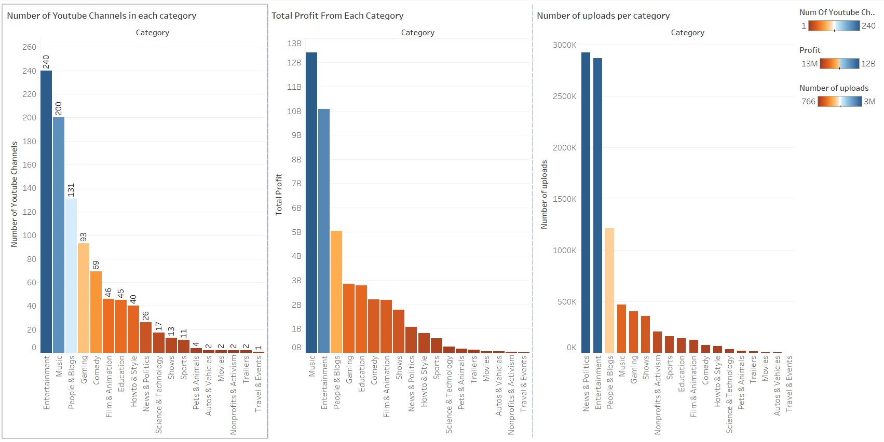

**Navigating the YouTube Landscape for Maximum Profitability**

**The Profit-Upload Paradox: News & Politics vs. Music**

When considering how to maximize earnings on YouTube, it's crucial to look at the interplay between the number of uploads and the profit generated in each category. For instance, the "News and Politics" category has a staggering 2.8 to 2.9 million uploads but generates around only $1 billion in profit. In stark contrast, the "Music" category rakes in a whopping $12.5 billion with just 500,000 uploads.

While it's true that music videos generally have higher production costs, the profit margin per video appears to be significantly higher in this category. This suggests that if you're looking to maximize profitability, "Music" might be a more lucrative avenue—although the genre and your entry strategy into music would require careful consideration.

**The Balanced Approach: Gaming**

Interestingly, "Gaming" strikes a balance between risk and reward. With only 93 channels in the top 1,000, this category still manages to generate around $3 billion in profit from approximately 400,000 uploads. This indicates a lower barrier to entry and a more balanced risk-reward ratio, making "Gaming" an attractive option for those looking to establish a name without taking on significant upfront risks.

**The Viewer Magnet: Entertainment**

The "Entertainment" category is a powerhouse on all fronts—it's second in revenue generation at $10 billion, has the highest number of channels at 240, and comes in second for the number of uploads with 2.6 million. This suggests that "Entertainment" is what viewers are most interested in, but it's worth noting that this category is broad and can encompass a wide range of content, from comedy sketches to random vlogs.

**Key Takeaways:**

**Profit Margins:** If you're looking for high profitability per video, the "Music" category appears to be the most promising, despite higher production costs.

**Low-Risk, High-Reward:** The "Gaming" category offers a balanced approach to profitability with a lower barrier to entry.

**Mass Appeal:** The "Entertainment" category is a strong contender for those looking to capture a broad audience but requires a well-thought-out content strategy due to its diverse nature.

By understanding these dynamics, aspiring YouTubers can make more informed decisions about which category to focus on, how to strategize their content, and what kind of investment they'll need to succeed.

**Subscribers, Country of Origin, and ViewCount**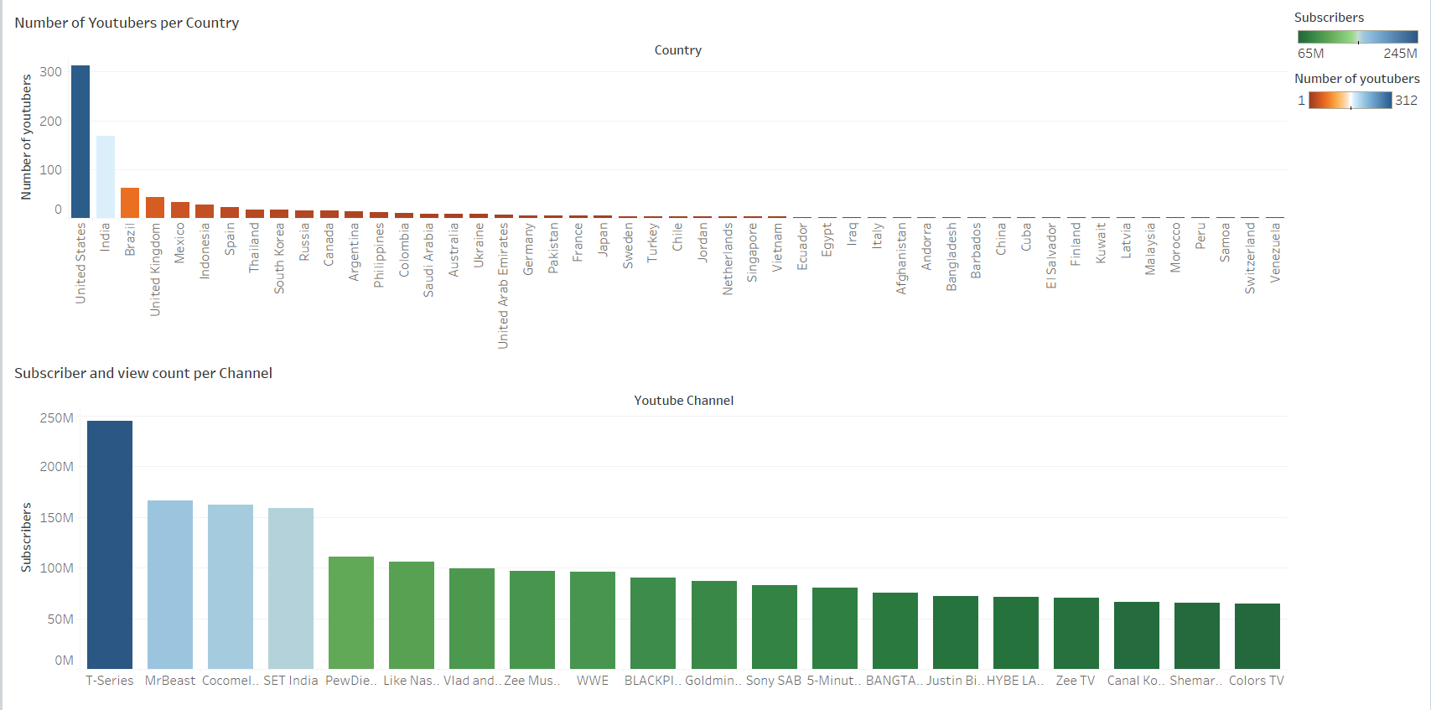

**Geographical and Category-Based Trends: The Road to YouTube Stardom**

**The Geographical Advantage: United States and India**

When it comes to geographical representation, the United States leads the pack with 312 channels in the top 1,000, followed by India with 168. Brazil trails in third place with 61 channels, and the numbers continue to taper off from there. This suggests that being based in the United States or India could offer a distinct advantage in terms of YouTube success, likely due to factors such as audience size, language, and cultural influence.

**The Category Titans: Music Channels**

In a surprising twist, the top 20 channels by subscriber count are overwhelmingly dominated by music video channels. Only a few exceptions exist—Mr. Beast and PewDiePie in the Entertainment/Gaming category, and Cocomelon, a children's content company. This indicates that breaking into the top echelons of YouTube fame may be particularly challenging for independent creators who aren't backed by music labels or large corporations.

**The Silver Lining: Profitability at Smaller Scales**

However, it's crucial to note that YouTube success isn't solely defined by making it to the top 20. Even channels with around 100,000 subscribers can generate a comfortable income. Therefore, aspiring YouTubers shouldn't be discouraged; there's room for profitability and success at various scales.

**Key Takeaways:**

**Geographical Leverage:** Being based in the United States or India could offer a head start in your YouTube journey due to larger potential audiences and cultural factors.

**Category Constraints:** While Music channels dominate the top ranks, other categories like Gaming and Entertainment also offer lucrative opportunities, albeit at a smaller scale.

**Scale and Profitability:** Success on YouTube doesn't necessarily require millions of subscribers; even smaller channels can achieve financial sustainability.

By understanding these geographical and category-based trends, aspiring YouTubers can better position themselves for success, tailoring their strategies to leverage existing advantages and navigate challenges.

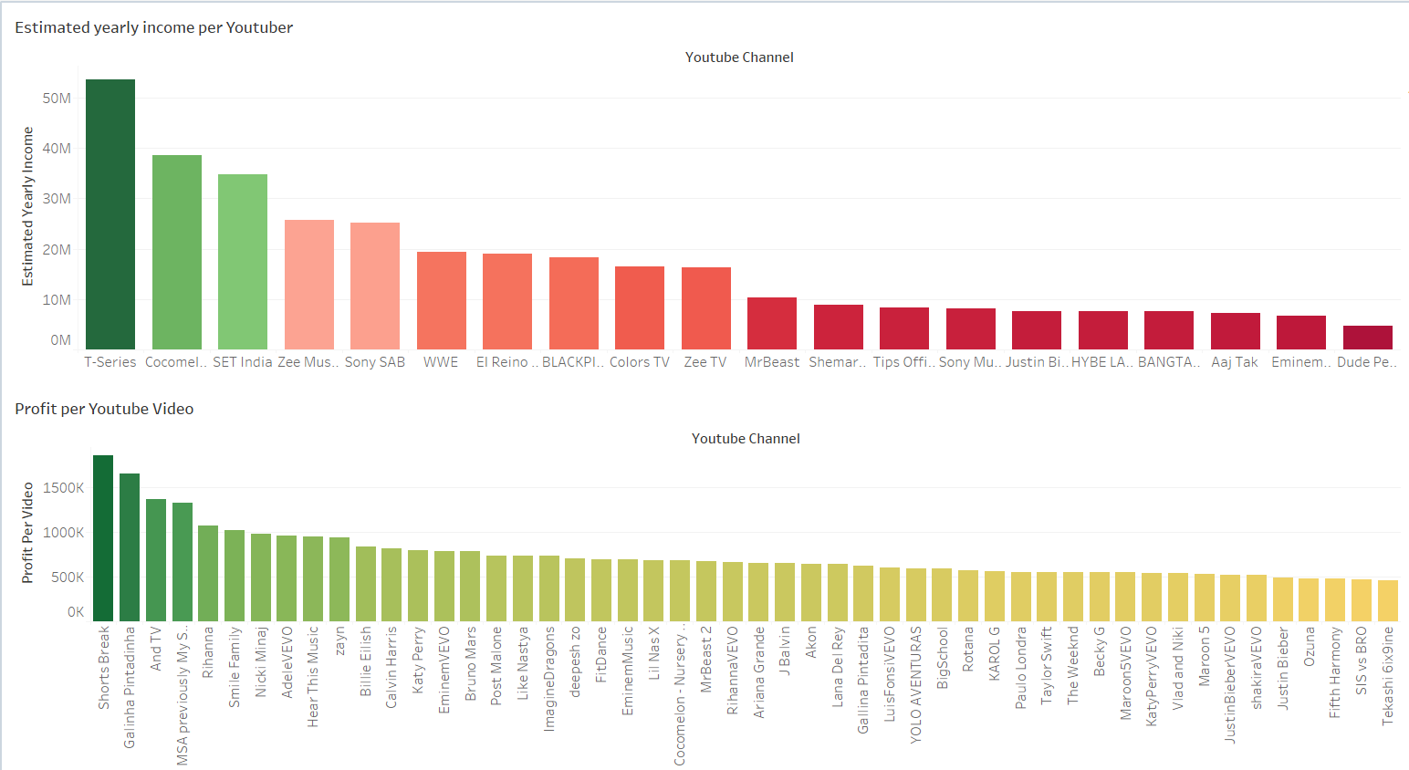

**Estimated yearly Income and Profit Per Youtube Video**

**The Reality Check: The Influence of Funding and Ad Revenue on YouTube Success**

**The Corporate Edge: Music and Sponsored Channels**

It's no secret that the music industry reigns supreme when it comes to profit per video. Channels backed by corporate sponsors and substantial funding often outperform independent creators in terms of yearly earnings since their launch. This is largely because these entities have the resources to invest in high-quality production and advertising, thereby attracting more viewers and, consequently, more ad revenue.

**The Independent Creator's Dilemma**

For those without the backing of major companies or sponsors, breaking into the top ranks of YouTube can be a Herculean task. This is especially true given that YouTube income is primarily generated through ad revenue, which can vary greatly. Factors affecting ad revenue include the number of ads in a video, the type of ads, whether ads are skippable, and even whether viewers are using ad blockers. For the purpose of this analysis, we assume an average earning of $4,000 per 1,000,000 views.

**The Silver Lining: Niche Categories**

However, all is not lost for the independent creator. By focusing on categories that are more accessible to individuals or small groups—rather than large corporations—there are still opportunities for meaningful success.

**Key Takeaways:**

**Corporate Advantage:** Major funding and corporate backing significantly boost a channel's potential for high earnings and visibility.

**Ad Revenue Variability:** Earnings can fluctuate based on various factors related to ad placement and viewer behavior.

**Opportunities in Niche Categories:** Independent creators can still find success by focusing on categories that are less dominated by corporate interests.

**A More Optimistic Approach**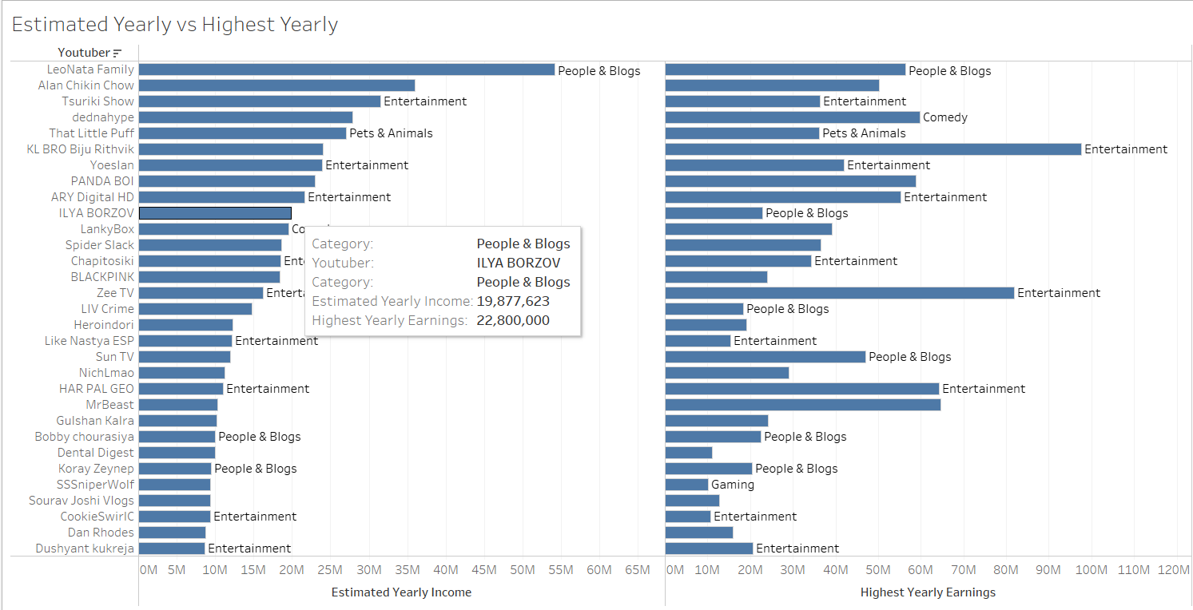

**Navigating Accessible Categories: A Closer Look at Opportunities for the Average YouTuber**

**The Accessible Avenues: Entertainment, People & Blogs, and More**

Shifting our focus to categories more accessible to individual creators or small teams, we find promising avenues in "Entertainment," "People & Blogs," "Gaming," "How-To & Style," and "Pets & Animals." Despite the dominance of corporate-backed channels in the overall landscape, these categories offer substantial earning potential. The estimated average yearly income in these categories peaks around a promising $5 million.

**The King and the Underdogs: Entertainment vs. Niche Categories**

While "Entertainment" continues to reign supreme in terms of viewer interest, it's important to note that less crowded categories like "People & Blogs" and "How-To & Style" also offer viable paths to success. Lower competition at the top could actually work in your favor, even if these categories attract fewer viewers overall.

**The Gaming Conundrum: Skill, Trends, and Popularity**

In the "Gaming" category, success isn't just about the content you create but also how well you play and the games you choose. Viewer preferences can be highly dependent on your skill level and the current popularity of the game you're playing. It's a category where trends can shift rapidly, making it challenging to maintain a top position over time.

**Key Takeaways:**

**Diverse Opportunities:** Categories like "Entertainment," "People & Blogs," and "How-To & Style" offer a broad range of opportunities for individual creators.

**Earning Potential:** Despite the challenges, the earning potential in these more accessible categories can be substantial, with average yearly incomes peaking around $5 million.

**Skill and Trends in Gaming:** Success in the "Gaming" category requires not just content creation skills but also gaming skills and a keen understanding of trends.

By focusing on these more accessible categories, aspiring YouTubers can find their own path to success, even if they don't have the backing of major sponsors or corporations.

**Conclusion: Navigating the YouTube Landscape—A Guide for Creators, Sponsors, and Investors**

**For Aspiring YouTubers:**

**Financial Backing:** Your initial funds can dictate the quality and quantity of your content. If you're starting small, consider focusing on niche categories like "People & Blogs" or "How-To & Style" where competition is less fierce but earning potential remains high.

**Team Size:** Solo creators can find success, but a small team can help diversify content and share the workload, particularly in editing and marketing.

**Networking:** Knowing people in the industry can give you a leg up, whether it's for collaborations, sponsorships, or insider tips.

**For Potential Sponsors:**

**Category Focus:** Sponsoring channels in "Entertainment" or "Gaming" may offer the most visibility, but don't overlook niche categories where engagement rates may be higher.

**Geographical Considerations:** Channels based in the United States and India tend to have larger audiences, but emerging markets could offer untapped potential.

**For Investors:**

**Emerging Talent:** Investing in up-and-coming creators in less saturated categories could yield high returns as they climb the ranks.

**Corporate Channels:** If you're looking for a safer bet, channels backed by corporations or major sponsors offer stability but may require larger initial investments.

**The Future of YouTube:**

YouTube as a platform continues to grow, both in terms of content diversity and user engagement. However, it's becoming increasingly commercialized, favoring creators with corporate backing or substantial financial resources.

**Final Recommendations:**

**For Creators:** If you're passionate and have a unique angle, there's still room to carve out your niche.

**For Sponsors:** Look beyond subscriber count and consider engagement and category relevance.

**For Investors:** YouTube remains a viable investment, but due diligence is crucial given the platform's evolving landscape.

In summary, whether you're an aspiring creator, a potential sponsor, or an investor, YouTube offers a plethora of opportunities. However, success requires a nuanced understanding of the platform's dynamics, a well-defined strategy, and, in many cases, the backing of financial resources.